**TABLEAU GETTING STARTED GUIDE**

To prepare for the upcoming Tableau lessons, please install the Student License as follow:

* [Download the most recent version of Tableau](http://www.tableau.com/tft/activation)
* Click on Download Tableau Desktop
* Be aware of what version you need: Mac or Windows
* Installation takes a bit. Be patient!
* Then enter this installation key: TCHQ-1AAF-CEE0-D10C-4351



After launching the above link,

Select “Get Started” to proceed.

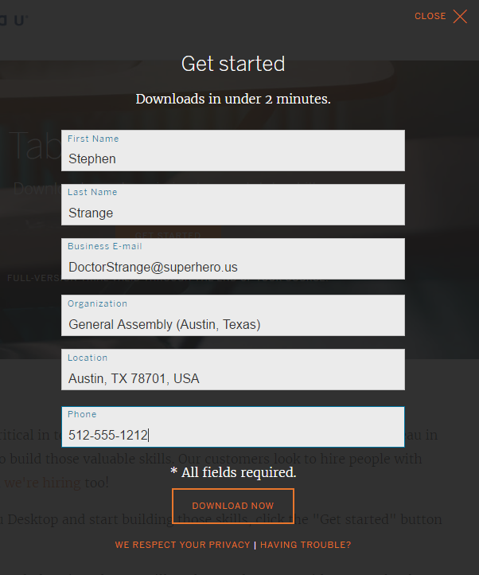

Which pops up a dialog screen to enter

your name, business email, and your

GA class information, as follows:

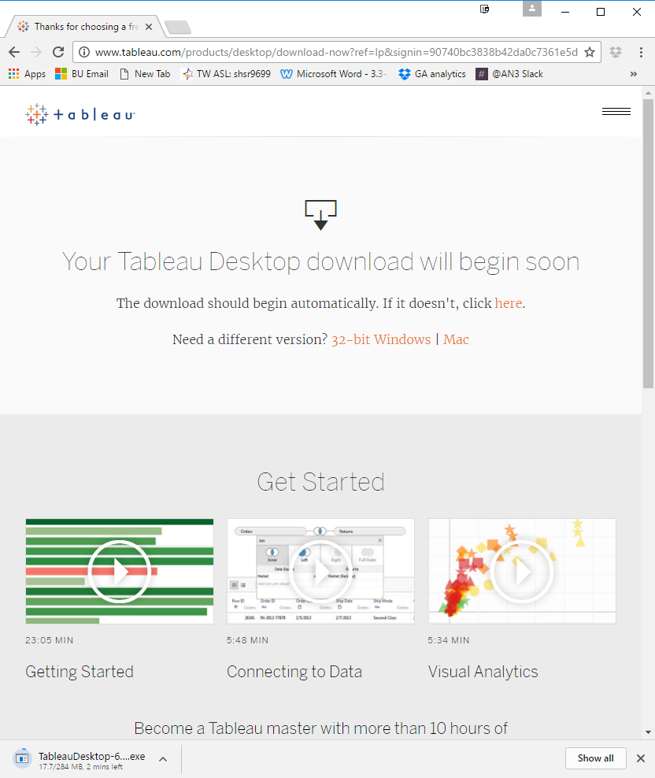

The download may take several minutes.

Consider the age of your computer system. Older systems may require the 32-bit version for Windows or Mac.

Look for the download time remaining on the browser status bar at the bottom.



Accept license agreement terms.

Click the “Install” button.

Version 10.3.1 was released

June 2017.

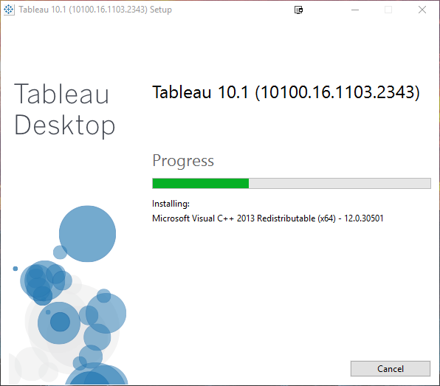

Tableau will install onto your computer system.

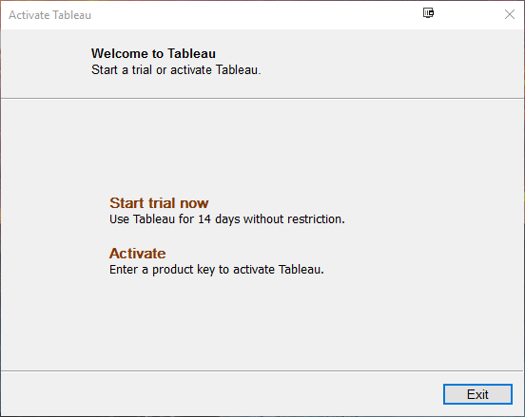

After installation is completed,  
select **Activate**.

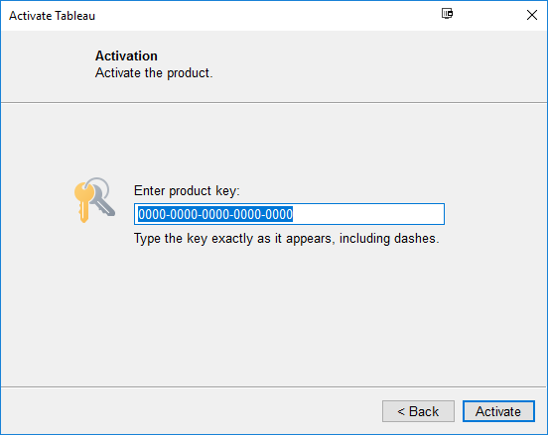

Enter (copy/paste) the class product activation code:

**####-####-####-####-####**

Click “Activate” once entered.

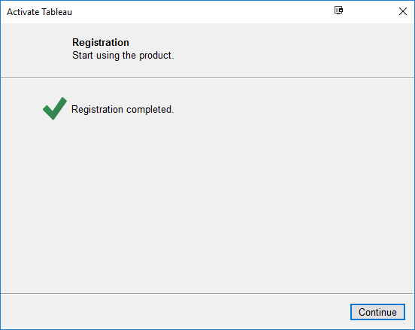

Click Continue.

You will then proceed to Tableau’s main screen, as shown below:

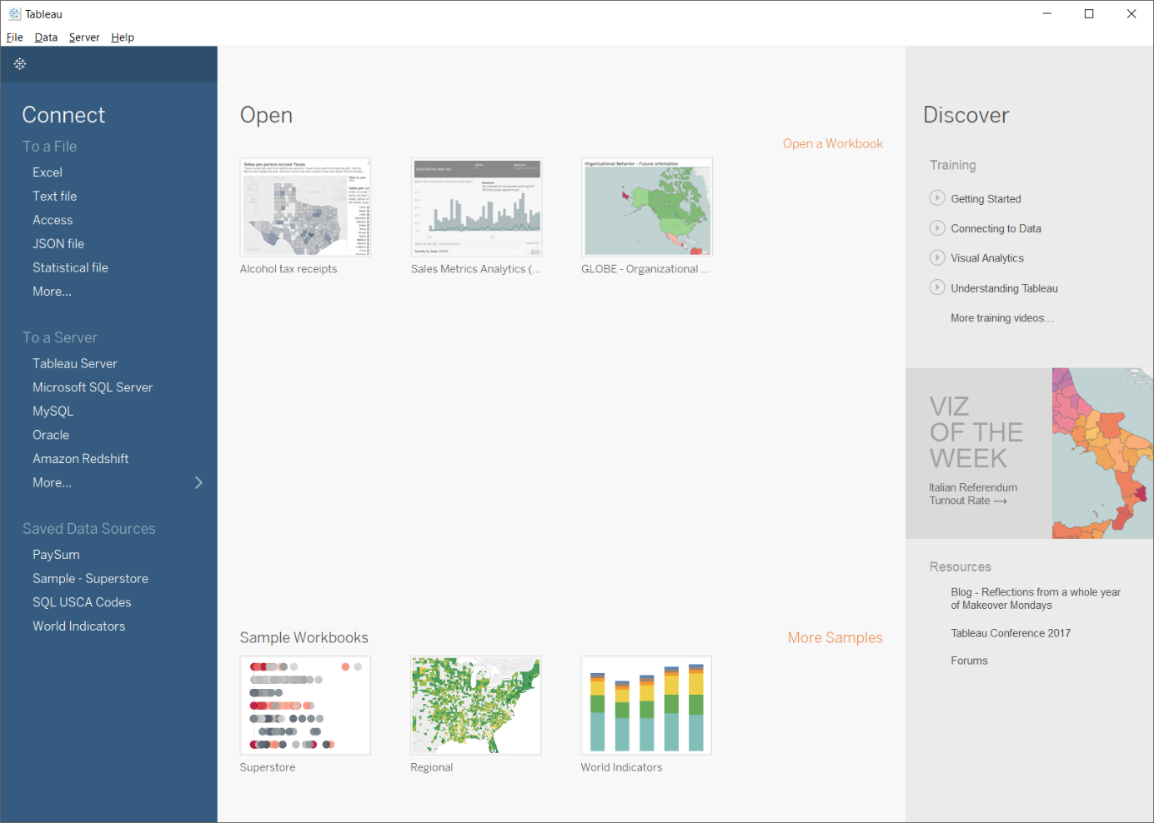

Before the next class, please watch all 3 videos in the Getting Started section, and the first 5 videos in the Connecting to Data section. Total viewing time is 60 minutes for all 8 videos. Download all sample data sets and workbooks and follow-along with each video.

